Harassment and discrimination reporting form

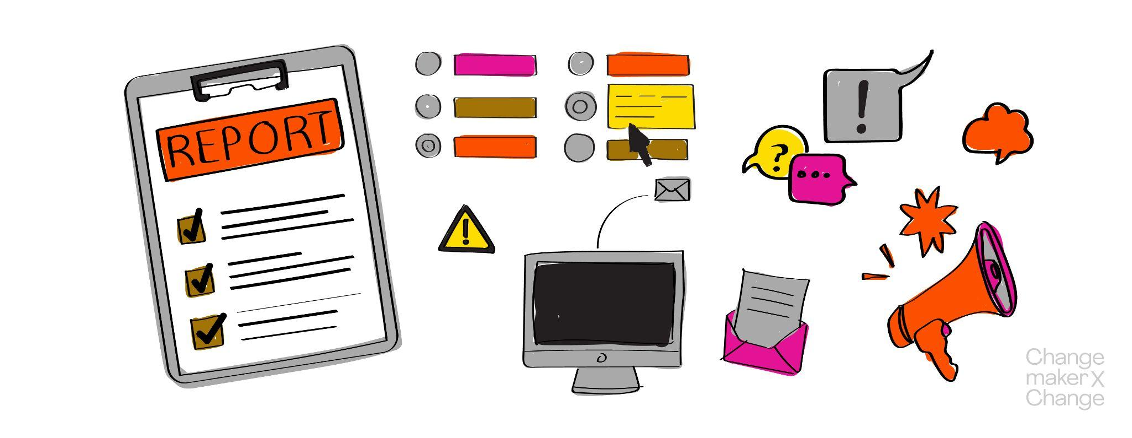

**Directions:** If you feel like you have been harassed or discriminated against, please fill out this form and return it to [wellbeing@changemakerxchange.org](mailto:wellbeing@changemakerxchange.org) or your local team of facilitators. We know that it can be hard to answer all these questions. Please, do not feel obliged to answer all of them. However, the information you provide will help us make sure that your experience can be dealt with adequately and we can provide you with the support you need. We can also assure you that no action will be taken against your will and without your explicit consent (exceptions are any legally binding actions). If you would like to fill this out together with a facilitator or host of your summit, please do not hesitate to contact your local team of facilitators.

It can be difficult to figure out when behaviour is offensive, transgressive, harassing or discriminating. As a guideline, if you experience another person behaving in a way or saying something that crosses your boundaries or makes you uncomfortable, it can be harassment. This can be both singular and repeated experiences. This does not mean that the person will necessarily face certain consequences, but it means that you can definitely come and talk to us. And if you want, you can report the experience, so that your case will be dealt with further. If you need to talk to someone about your experiences – even if you are in doubt about what you have experienced – you are always welcome to contact your local facilitators team.

**Name:**

**Date of complaint:**

**Interviewed by:**

**Basis of discrimination (please underline):** Sex (Gender); Race; Colour; Retaliation; Age; Religion; Creed; National Origin; Disability; Sexual Orientation; Marital Status; Others: please specify _____________________

**Individual(s) who you felt harassed/discriminated by:**

1. ____________________________________
2. ____________________________________
3. ____________________________________

**Please describe what happened. If possible, please include dates and as much detail as possible.**

**To your knowledge, did anybody else witness what happened? If so, who (we may need to speak with them as part of our investigation) and what do you believe they witnessed?**

**Was any of the discrimination or harassment being reported in written form or recorded? If yes, would you be okay to share it with CXC confidentially to aid our investigation?**

**What resolution to this issue would make you feel safest?**

**Are there any other individuals you want ChangemakerXchange to contact regarding your experience and your report? If so, who do you wish contacted and why?**

**Is there anything else you would like us to know?**

**Acknowledgement:** To investigate the experience you reported, it might be necessary to interview you, the alleged harasser(s), and any witnesses with knowledge of what happened. ChangemakerXchange will notify all persons involved in the investigation that it is confidential and that unauthorised disclosures of information concerning the investigation could result in disciplinary action, up to and including termination of employment / involvement in the community.

The information provided in this report is true and correct to the best of my knowledge. I am willing to cooperate fully in the investigation of my case.

________________________________ ________________________________

*Signature* *Date*

| **ChangemakerXchange Official Use Only** |
| --- |

**Date of alleged violation:**

**Person filing charge:**

**Place of alleged violation:**

**Basis of discrimination (please underline):** Sex (Gender); Race; Colour; Retaliation; Age; Religion; Creed; National Origin; Disability; Sexual Orientation; Marital Status; Others: please specify _____________________

**Circumstances of alleged violation:**

**Date:**

_________________________________

*Printed name of CXC team member*

_________________________________

*Signature of CXC team member*